Observations (tige et feuilles)

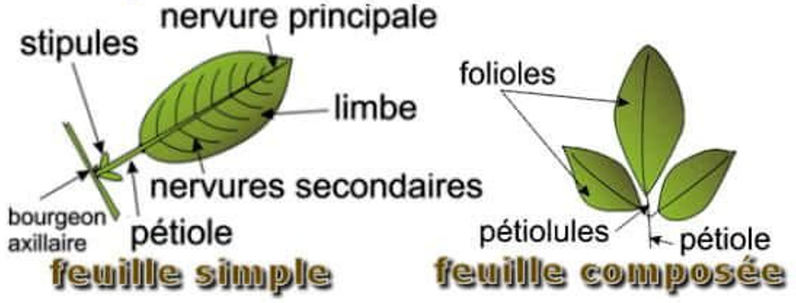
Bordure du limbe
entière dentée crénelée lobée ondulée denticulée épineuse
Disposition des feuilles sur la tige
alterne opposée hélicoïdale verticillée
Fixation de la feuille sur la tige
pétiolée sessile embrassante engainante perfoliée
Taille de la plante

………………. cm
Forme de la tige
ronde carrée concave convexe trigone aplatie
lisse poilue verruqueuse épineuse annelée
Dessin de la plante | Informations complémentaires  ………………………………………………………………………………  ………………………………………………………………………………  ………………………………………………………………………………  ………………………………………………………………………………  ………………………………………………………………………………  ………………………………………………………………………………  ………………………………………………………………………………  ………………………………………………………………………………  ………………………………………………………………………………  ………………………………………………………………………………  ………………………………………………………………………………  ………………………………………………………………………………  ………………………………………………………………………………

Observations (fleur)

Type d’inflorescence
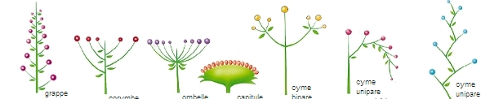
grappe corymbe ombelle capitule cyme
Disposition des feuilles sur la tige
alterne opposée hélicoïdale verticillée
Fixation de la feuille sur la tige
pétiolée sessile embrassante engainante perfoliée
Taille de la plante

………………. cm
Forme de la tige
ronde carrée concave convexe trigone aplatie
lisse poilue verruqueuse épineuse annelée
Dessin de la plante | Informations complémentaires  ………………………………………………………………………………  ………………………………………………………………………………  ………………………………………………………………………………  ………………………………………………………………………………  ………………………………………………………………………………  ………………………………………………………………………………  ………………………………………………………………………………  ………………………………………………………………………………  ………………………………………………………………………………  ………………………………………………………………………………  ………………………………………………………………………………  ………………………………………………………………………………  ………………………………………………………………………………

