Je cherche des informations sur chaque personnage et je rédige une biographie
( Dates de naissance / de mort lieu de naissance/ de mort principaux événements de sa vie)

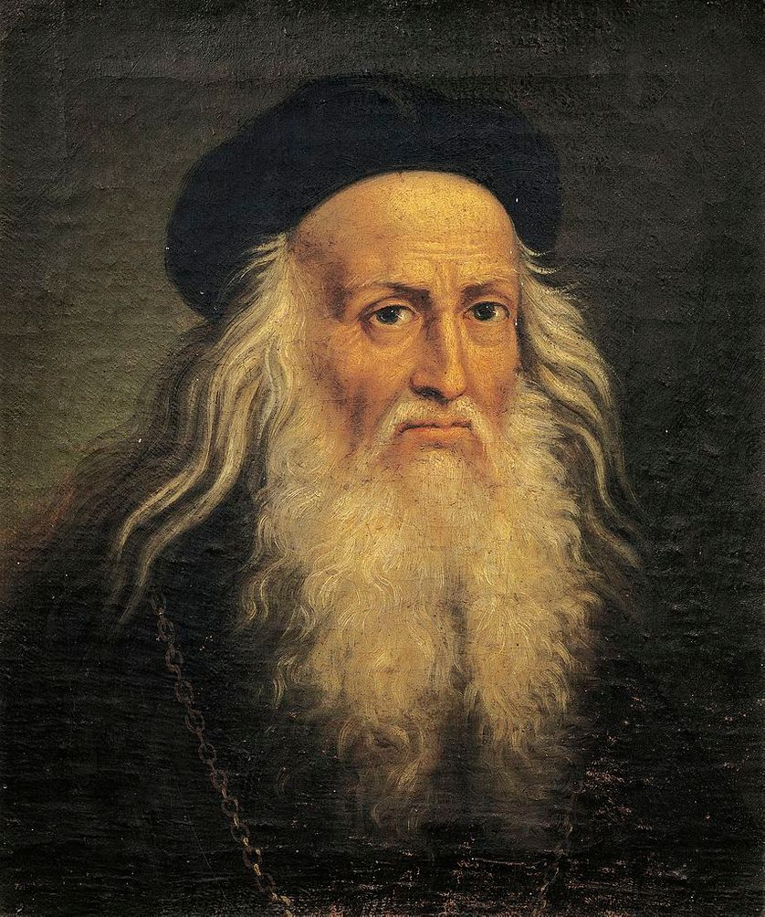  Léonard  de Vinci | ………………………………………………………...............................................................................................  …………………………………………………………………………………………............................................................  …………………………………………………………………………………………...........................................................  ………………………………………………………………………………………..............................................................  …………………………………………………………………………………………............................................................  …………………………………………………………………………………………...........................................................  ………………………………………………………………………………………….........................................................  ………………………………………………………………………………………............................................................
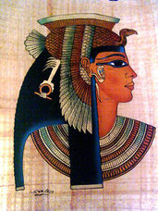  Cléopatre | ………………………………………………………...............................................................................................  …………………………………………………………………………………………............................................................  …………………………………………………………………………………………...........................................................  ………………………………………………………………………………………..............................................................  …………………………………………………………………………………………............................................................  …………………………………………………………………………………………...........................................................  ………………………………………………………………………………………….........................................................  ………………………………………………………………………………………............................................................
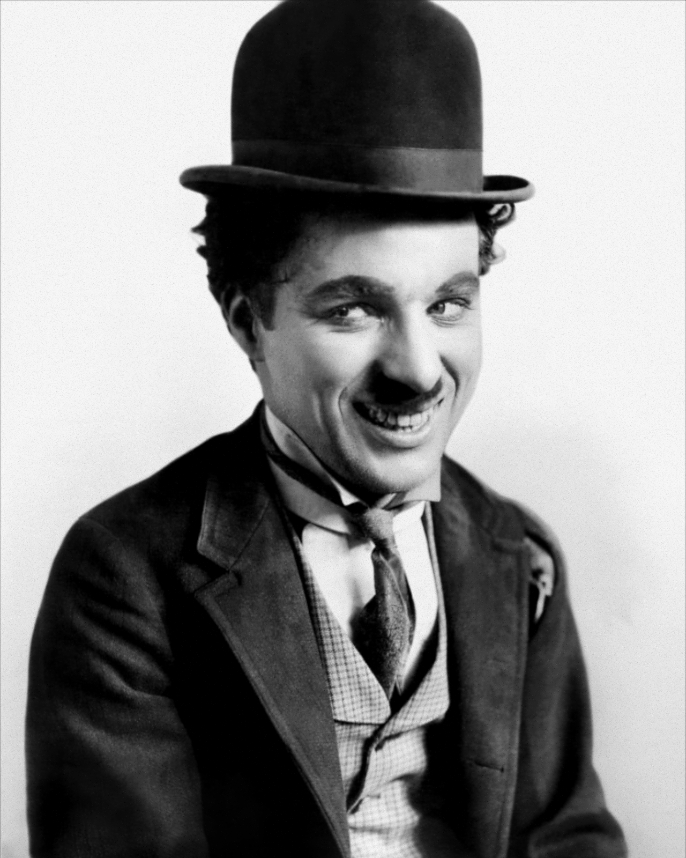  Charlie Chaplin | ………………………………………………………...............................................................................................  …………………………………………………………………………………………............................................................  …………………………………………………………………………………………...........................................................  ………………………………………………………………………………………..............................................................  …………………………………………………………………………………………............................................................  …………………………………………………………………………………………...........................................................  ………………………………………………………………………………………….........................................................  ………………………………………………………………………………………............................................................

